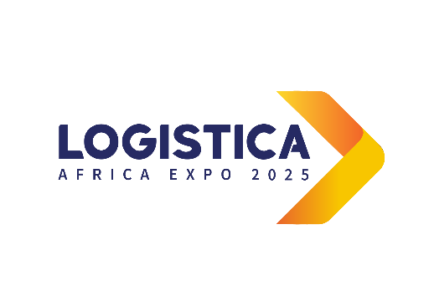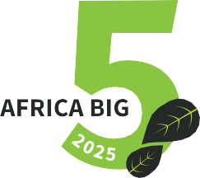



**Under the patronage**

**of The Prime Ministry - Republic of Tunisia**

The Transport Ministry

**Guidelines for Abstract Submission**

**LOGISTICA AFRICA EXPO 2025**

**08-11 April 2025, El Kram Expo Center, Tunis - Tunisia**

**LOGISTICA AFRICA 2025 Topics**

1. Information Systems, Artificial Intelligence, and Big Data in Logistics
   1. Automation and Robotization of Logistics Chains
   2. Information and Communication Technologies (ICT), Warehouse Management, Inventory, Order, and Delivery Management
   3. Blockchain and Supply Chain Management
   4. Big Data and Logistics Strategies
   5. Advanced Geolocation Technologies
   6. Cloud Computing in Logistics
   7. Artificial Intelligence and Logistics Performance
   8. Digitalization, Risk Management, and Logistics Performance
2. Logistics – Sustainability – Resilience
   1. Green Logistics
   2. Elastic Logistics
   3. Digitalization and Sustainable Logistics
   4. The Supply Chain and Social Development
   5. Environmental Performance of the Supply Chain
   6. Reverse Logistics and Returns Management
3. International Transport and Customs
   1. Multimodal Transport
   2. Digitalization and Automation of Ports
   3. International Transport and Export Competitiveness
   4. International Transport Infrastructure and Attractiveness of International Trade Flows
   5. Decarbonization of Maritime and Air Transport
   6. Rail Transport and Territorial Integration
   7. Technological Innovations and Management of International Transport Chains
   8. Security and Safety in International Transport
   9. Digitalization of Customs Procedures

**Submission Guidelines**

1. Abstracts must be submitted by 20 February 2025.
2. Ensure your abstract adheres to the conference theme.
3. Use the required format for the abstract; as mentioned in the following page. Other formats are not accepted for submission.
4. Submit your abstract form via **conference2025@logisticaafricaexpo.org**

**Registration Fees for Accepted Abstracts**

450 $ for the Author.

300 $ for the co-Author.

**Please fill in the Abstract Form on the Following Page**





**Under the patronage**

**of The Prime Ministry - Republic of Tunisia**

The Transport Ministry

**Abstract Form**

**LOGISTICA AFRICA EXPO 2025**

**08-11 April 2025, El Kram Expo Center, Tunis – Tunisia**

Main Author's Full Name: ...................................................................................................................................................

Job Title: ..................................................................................................................................................................................

Company/Organization: ..........................................................................................................................................................

Email Address: .................................................................................................................................................................................................................................................

Co-authors: .....................................................................................................................................................................................................................................................

Phone/WhatsApp Number: ...........................................................................................................................................................................................................

Has this work been presented previously? If yes, please provide details (Conference name, and dates):

.....................................................................................................................................................................................................................................................................................

Abstract Title: ……………………………………………………………………………………………………………………………….

Topic: ………….…………………………………………………………………………………………………………...........................

## Abstract Content ( Max. 500 Words)

The International Logistics Africa Conference is a pivotal event that plays a crucial role in shaping the future of the logistics and transportation sector. By bringing together researchers, professionals, and stakeholders, the conference creates a unique environment where diverse perspectives converge to address pressing issues and explore innovative solutions. This gathering is not merely a networking opportunity; it serves as a catalyst for change and modernization within the industry.

One of the primary objectives of the conference is to foster exchanges and networking among participants. By creating a dedicated space for interaction, the event encourages attendees to share their insights, experiences, and best practices. This exchange of ideas is vital for the continuous improvement of logistics and transportation processes. When professionals from different backgrounds come together, they can identify common challenges and collaborate on effective strategies to overcome them. This collaborative spirit is essential for driving innovation and ensuring that the industry adapts to the rapidly changing global landscape.

Moreover, the conference emphasizes the importance of research and innovation in the logistics sector. By highlighting the latest advancements in logistics and transportation technologies, the event encourages participants to stay informed about emerging trends and practices. This focus on innovation is critical, as the logistics industry faces numerous challenges, including increasing demand for efficiency, sustainability, and digitalization. By promoting collaborations between academia and industry, the conference helps bridge the gap between theoretical research and practical application, ensuring that innovative solutions are effectively implemented in real-world scenarios.

In addition to fostering innovation, the conference aims to raise awareness of the sector's challenges. Participants are informed about current and future issues, such as sustainability, digitalization, and supply chain management. These topics are increasingly relevant in today's world, where businesses must navigate complex global supply chains while minimizing their environmental impact. By offering conferences and workshops on these subjects, the event equips attendees with the knowledge and tools necessary to address these challenges head-on.

The focus on skill development is another significant aspect of the conference. As the logistics environment continues to evolve, professionals must adapt to new technologies and methodologies. The conference provides training and professional development sessions that address the competencies required in this dynamic landscape. By investing in the development of human capital, the event ensures that participants are well-prepared to meet the demands of the industry and contribute to its growth.

## Short Biography (Max. 150 Words)

Bbbb is a leading expert in the field of transportation and logistics, with several years of experience in managing strategic projects on an international scale. Recognized for his innovative approach, he has successfully optimized supply chains and developed sustainable logistics solutions while promoting regional collaboration and capacity building within the industry. His in-depth expertise has enabled him to lead complex initiatives that have transformed the operations of numerous companies, marking his professional journey with significant achievements in optimizing logistics processes, risk management, and improving operational efficiency.

Bbbb has successfully managed large-scale projects, ensuring adherence to timelines and budgets while achieving measurable results. Through an analytical approach, he identifies areas for improvement and proposes tailored solutions to maximize logistics performance. By integrating advanced technologies, he enhances the traceability and transparency of operations, thereby facilitating informed decision-making.

As a thought leader in the sector, Bbbb regularly shares his expertise at conferences and workshops, contributing to shaping the future of transportation and logistics. contemporary challenges.

****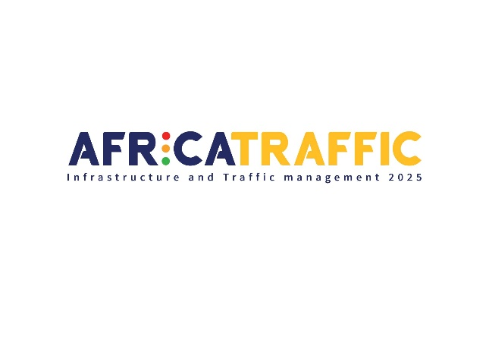



**Under the patronage**

**Of The Prime Ministry - Republic of Tunisia**

The Transport Ministry

The **Equipment and Housing Ministry**

**Guidelines for Abstract Submission**

**AFRICA TRAFFIC 2025**

**08-11 April 2025, El Kram Expo Center, Tunis - Tunisia**

**AFRICA TRAFFIC 2025 Topics**

1. Urban Mobility Analysis
   1. Economics and Politics of Urban Mobility
   2. Land Use Planning, Transportation, and Urban Mobility
   3. Geography of Urban Transportation
   4. Public Transport Management
   5. Road Traffic Management
   6. Intelligent Transport Systems
   7. Intelligent Parking Systems

2. Transport – Energy – Environment

* 1. Transportation and Energy Consumption
  2. Transportation and Pollutant Emissions
  3. Decarbonization of Transportation Activities
  4. Electric Mobility
  5. Sustainable Mobility: Cycling and Walking
  6. Energy Efficiency in Transportation

1. Transport Safety and Security
   1. Road Safety
   2. Information Systems and Road Safety Management
   3. Road Safety Policy
   4. Analysis of Road Accidents

**Submission Guidelines**

1. Abstracts must be submitted by 20 February 2025.
2. Ensure your abstract adheres to the conference theme.
3. Use the required format for the abstract; as mentioned in the following page. Other formats are not accepted for submission.
4. Submit your abstract form via **conference2025@logisticaafricaexpo.org**

**Registration Fees for Accepted Abstracts**

450 $ for the Author.

300 $ for the co-Author.

**Please fill in the Abstract Form on the Following Page**



**Under the patronage**

**Of The Prime Ministry - Republic of Tunisia**

The Transport Ministry

The **Equipment and Housing Ministry**

**Abstract Form**

**AFRICA TRAFFIC 2025**

**08-11 April 2025, El Kram Expo Center, Tunis - Tunisia**

Main Author's Full Name: ...................................................................................................................................................

Job Title: ..................................................................................................................................................................................

Company/Organization: ..........................................................................................................................................................

Email Address: .................................................................................................................................................................................................................................................

Co-authors: .....................................................................................................................................................................................................................................................

Phone/WhatsApp Number: ...........................................................................................................................................................................................................

Has this work been presented previously? If yes, please provide details (Conference name, and dates):

.....................................................................................................................................................................................................................................................................................

Abstract Title: ……………………………………………………………………………………………………………………………….

Topic: ………….…………………………………………………………………………………………………………...........................

## Short Biography (Max. 150 Words)

Bbbb AAAA is a distinguished expert in the energy and petroleum industry with over X years of experience driving impactful projects across Africa and beyond. As a leading voice in the sector, Bbbb has held key roles in [notable companies or organizations], focusing on exploration, production, and energy policy development.Passionate about sustainable energy solutions, Bbbb actively works on integrating renewable technologies and advancing innovative practices to address the challenges of energy transition. A strong advocate for regional collaboration, Bbbb has contributed to initiatives that promote investment, local content development, and capacity-building across Africa’s energy landscape.As a sought-after speaker, Bbbb regularly shares insights on the future of energy at international conferences, shedding light on Africa’s vast potential in shaping global energy markets. Committed to empowering communities, Bbbb champions diversity, inclusivity, and the next generation of leaders in the energy industry.

## Abstract Content ( Max. 500 Words)

AFRICA TRAFFIC 2025 aims to provide a platform for discussion and debate on critical issues such as energy, air pollution, safety, public transport, as well as traffic and parking management. Additionally, it will explore the impact of new information and communication technologies, including big data, artificial intelligence (AI), and the Internet of Things (IoT), on these challenges.

The necessity for an integrated approach to tackle urban mobility challenges has never been more pressing. Cities around the world are facing increasing problems of congestion, pollution, and road safety, which require innovative and sustainable solutions. This conference will bring together researchers, experts, and representatives from public authorities and non-governmental organizations from various countries, all committed to researching and implementing solutions to improve urban mobility in all its dimensions.

The event is open to a wide range of disciplines, encompassing the social sciences, engineering, urban planning, and health. This interdisciplinary diversity will facilitate theoretical and methodological discussions, as well as practical workshops to study empirical cases. Participants will have the opportunity to share their experiences, exchange ideas, and collaborate on projects aimed at promoting sustainable urban mobility.

Issues related to energy and air pollution will be at the forefront of discussions. Experts will address the links between transportation modes, energy consumption, and greenhouse gas emissions, while exploring solutions such as electric mobility and public transport. Road safety will also be a central topic, with analyses of safety policies and information systems for risk management.

Traffic and parking management is another crucial aspect that will be examined. Participants will discuss best practices for optimizing urban circulation, reducing congestion, and improving access to transportation infrastructure. The integration of new technologies, such as intelligent transport systems and parking management applications, will also be explored as a means to enhance the efficiency and safety of transportation systems.

AFRICA TRAFFIC 2025 represents a unique opportunity to bring together key stakeholders in the field of urban mobility to discuss the challenges and opportunities that lie ahead. By fostering interdisciplinary dialogue and encouraging collaboration among researchers, practitioners, and policymakers, this event aims to contribute to the development of more sustainable and resilient cities. The outcomes of these discussions could have a significant impact on urban mobility policies, inspiring innovative solutions and strengthening collective commitment to a more sustainable future.

Our conference focused on traffic problems are vital for fostering collaboration among experts, policymakers, and community stakeholders. They provide a platform to share innovative solutions, discuss best practices, and explore the integration of new technologies, ultimately leading to more effective strategies for managing congestion and improving urban mobility.